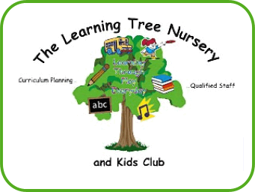

Special educational needs and disabilities policy

Aim of this policy

To provide an inclusive environment in which all children, including those with special educational needs or disabilities, are supported to reach their full potential.

Policy
The setting has regard for The SEND Code of Practice 2014 for the Early Years (DfE). The setting’s designated Special Educational Needs Co-ordinator (SENCO) is Emma Raisbeck. This is also identified in our handbook for parents. The setting has developed a local offer which outlines how the setting supports the needs of all children and their families; this can be found on the settings website www.thelearningtreenursery.co.uk.

The Learning Tree ensures that our provision is inclusive to all children with special educational needs and or disabilities (SEND) and practitioners help support parents and children SEND. We identify the specific needs of children with special educational needs and meet those needs through a range of strategies, working in partnership with parents and other agencies to meet individual children's needs. We monitor and review our policy, practice and provision and, if necessary, make reasonable adjustments to our practice and provision to suit the child and families’ needs. We ensure that the provision for children with SEND is the responsibility of all members of the setting.

We provide parents with information on sources of independent advice and support for example, speech and language drop in sessions at local children’s centres. We liaise with other professionals involved with children with special educational needs and their families, including transition arrangements to other settings and schools. Child or young person views to be considered. We ensure that parents are informed at all stages of the assessment, planning, provision and review of their children's education.

We have systems in place for supporting children during Targeted and Specialist support Statutory Assessment. This involvement may be from Early Years Support Teachers, Occupational Therapists, Speech and Language Therapists, Physiotherapists, Educational Psychologists or Specialist Support Teachers (e.g. visual impairment, hearing impairment). The settings SENCO attends regular training update sessions. We use a system of planning, implementing, monitoring, evaluating and reviewing individual Learning Provision plans (ILPPs) for children with special educational needs and ensure that children with special educational needs are appropriately involved taking into account their levels of ability and keep records of the assessment, planning, provision and review for children with special educational needs. Additional staff training is prioritised when required.

We provide resources (human and financial) to implement our special educational needs policy and with parental permission, we are able to apply for Inclusion funding from North Yorkshire County Council.

We ensure the effectiveness of our special educational needs and disabilities provision by collecting information from a range of sources e.g. Individual Learning Provision Plan reviews, team and planning meetings, parental and external agency's views, this information is collated, evaluated and reviewed as and when required.
.
Links to other policies

Complaints
Safeguarding
Equal opportunities
Health and safety

