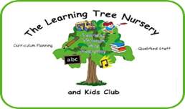

Newsletter March 2018
Dear Parents/Carers
Mrs Baker’s Retirement
Mrs Baker is retiring at the end of March, she has been a huge part of The Learning Tree for 20+ years. We are happy to say that she is still going to be a part of The Learning Tree as she has taken on a Holding Trustee position within the committee and she is also still going to come in on a voluntary basis from time to time. I know that she will be greatly missed by parents, children and staff. She has seen a lot of children, and even some parents, go through the nursery and kid’s club! I am sure that you will want to join us in wishing her a very long and happy retirement.
If you would like to make a contribution towards a retirement gift for Mrs Baker please just speak to Emma or Lisa. We are hoping to do a presentation on Thursday 29th March which you are welcome to join us for.

Easter Craft
As some of you will be aware we usually do an Easter Craft morning, however, with Easter falling early this year we have decided to have an open session later in the year. Hopefully the weather will have brightened up by then and some of you will be able to join in with some outdoor activities!

Story Reading
We would really love for some parents, carers or grandparents etc. to come in and read a favourite story to a small group of children. Please speak to Lisa if you would be able to spare 5-10 minutes to do this. Sharing stories is a really important part of children’s communication and language development.

Facebook Page
I not sure if you are all aware but we do have a Facebook page. Please Like and Follow our page as over the past few weeks I have used it to share important messages such as our closure due to the bad weather, and messages about our trip to Flamingo Land. I know we all use social media now so this is the fastest way for me to get messages out to you all.

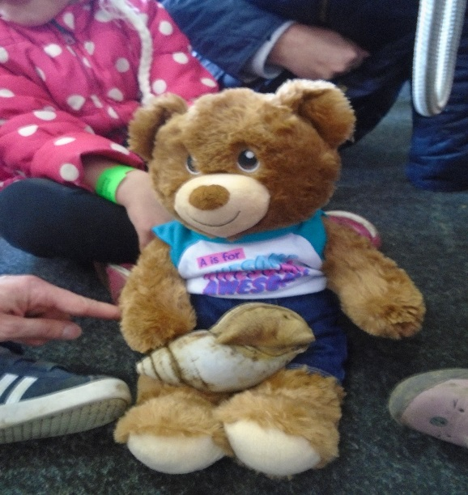
Alex the Nursery Bear
We now have a nursery bear, he/she is called Alex. If you have any visits, holidays or just exciting activities happening at home please take Alex to join in with you. He came along to Flamingo Land with us and some of the children may have already told you about him/her. We are going to put a diary together to share Alex’s adventures.

Wanted!!
We would like donations of the following items:-
Buttons, ribbons, funnels, keys, fabric scraps, wooden pegs, nuts and bolts, chains, shells, feathers, pine cones, corks, pipes. These items are known as ‘Loose Parts’.

What are loose parts?
“Loose parts are the opposite of toys. Toys are designed with specific purposes; loose parts are not.
The concept of “loose parts” is understood by children worldwide; any child noticing odds and ends lying about will instinctively pick them and put them to use. This is because children have active hands and active minds with a gift for seeing possibilities that adults miss.
In open-ended play children, themselves decide what to do, how to do it and what to use. For children who immerse in it, open-ended play evolves in amazing ways. Initially, it consists of fluid experimentation. Over time it becomes increasingly purposeful as children start to plan what to act out or invent.
Loose parts can be small as corks or as large as drain pipes – healthy imagination finds uses for them all!

We would also like trinket boxes, stainless steel items, such as, tea services, goblets, measuring scoops, animal ornaments, brass items, little nick nack items!
This might seem a strange ask but the children love exploring and playing with these items. We are sure that many of you or family members will have these kind of items at home.
Here are some photos of examples of items we already have,
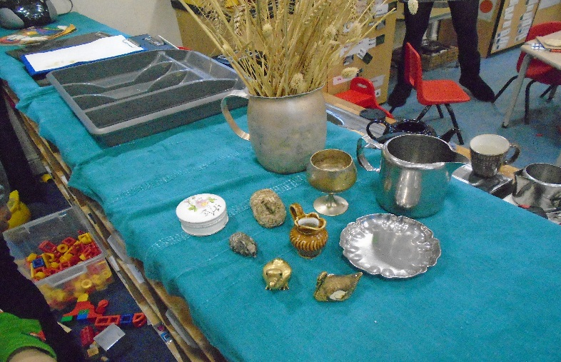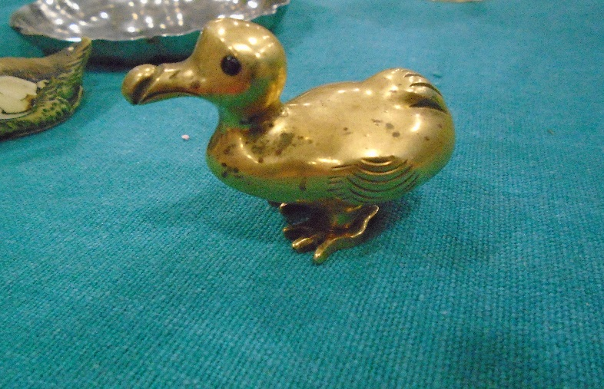

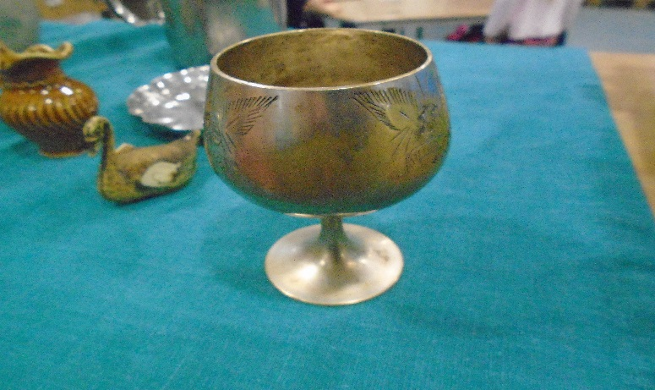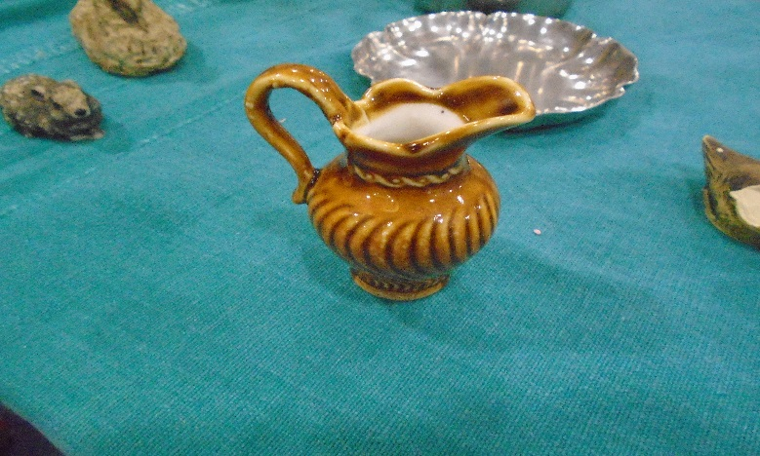

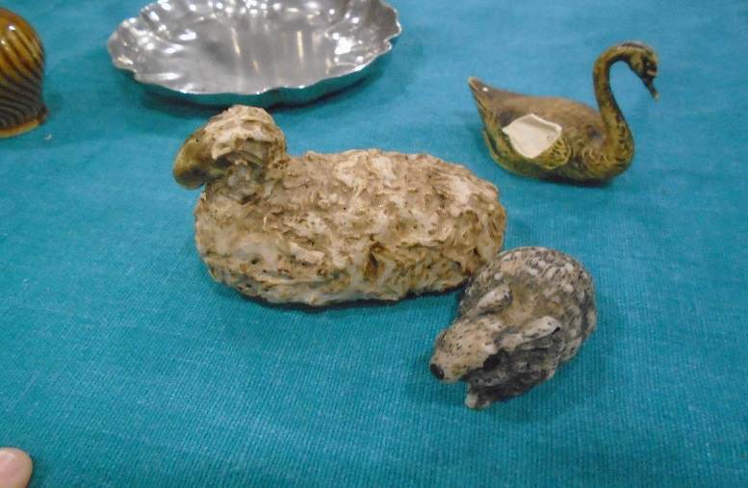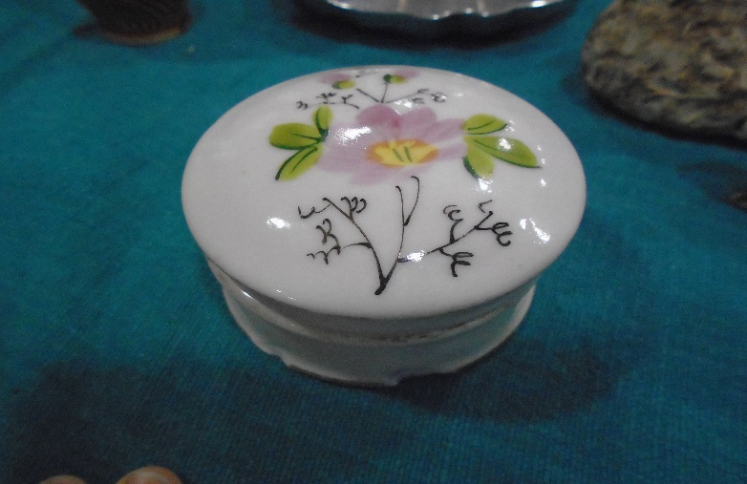

Dressing up
We would also like hats, in particular flat caps, waistcoats and jackets for our dressing up area.

Absences, Illnesses and Medical updates
Please may we remind you that we must receive a telephone call to inform us of any absences due to illnesses. It is important that we receive this call before 9.30am due to us having to let the school kitchen know how many hot dinners we would like. Also if your child is going to be late in but you would like them to have a hot dinner please give us a ring and let us know.
Also if your child is going to be absent from their usual sessions for any other reason, including holidays, you must inform us asap. If your child is prescribed a course of anti-biotics they must remain off nursery for 24 hours following the first dose of the medication being administered.
Please may we also ask that if your child develops any allergies, is diagnosed with an illness at any point after joining us or if any medical information previously provided changes, that you inform us in writing asap.
Session Times
Can I please ask all parents not to arrive before their child’s booked arrival time and to collect promptly at the end of your booked session. This is a safeguarding issue and is to allow us to maintain staff:child ratios at all times.
Kind Regards
Emma and the rest of the team at The Learning Tree

